Quick Operation Manual
Digital video recorder

The series DVR is designed specially for security and surveillance field which is an outstanding digital surveillance product. It introduces embedded LINUX operating system which is more stable. It introduces standard H.264mp video compressed format and G.711A audio compressed format which insures the high quality image and low error coding ratio. Strong network services greatly enhance the network data transmission capacity and remote control capabilities.
The First Part: Basic Operation

1 Basic Installation

1.1 Hard Disk Installation
For the first use，please install the hard disk.
Full Function series DVR support 2 Sata hard disks, and Simple Function series DVR support 1 Sata hard disk.
Note: DVR can run and monitor normally without hard disk, while it can’t record and playback.

1.2 Mouse Connection
Full Function series DVR has 1 USB at back panel and 1 USB at front panel,the 2 USB could be used for mouse,Flash stick,3G&WIFI module,movable HDD and USB DVR-RW.
Simple Function series has two USB at back panel for mouse and flask stick
2 Turn on
Plug the power supply and turn on the power supply switch. Power supply indicator light shining indicates turning on the video recorder. After finishing the startup you will hear a beep, and the default setting of video output is multiple-window output mode.
Note: Restart the power after the abnormal power off, DVR will automatically recover the state before power off.

3 Turn off
There are two methods to turn off the DVR which are soft switch and hard switch. Entering [Main menu] and choosing [Logout] in the [turn off the system] option is called soft switch. Pressing the power supply switch is called hard switch.
Note: The setting information must be saved before replacing the battery otherwise information will lose.

4 Login
When the DVR boots up,user must login and the system provides the corresponding functions with the user purview. There are two user settings which are admin, and guest; and they have no passwords. “Admin” is the super user purview; “Guest” is the common user purview.
Password protection: If the password is continuous wrong three times, the alarm will start. If the password is continuous wrong five times, the account will be locked. (Through reboot or after half an hour, the account will be unlocked automatically).
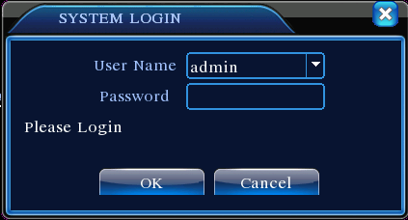
Picture1 Login
For your system security, please modify your password after first login.

5 Preview
Login normally and choose the multi-menu preview status.
The system date, time and channel name are shown in each viewing window. The surveillance video and the alarm status are shown in each window.
1 |  | Recording status | 3 |  | Video loss
2 |  | Motion detect | 4 |  | Camera lock
Table1 Preview icon

6 Recording Config
Set the recording parameters in the surveillance channel. You can enter [Main Menu]> [Record]> [Record Config] to set. The system’s default set is 24 hours continuous recording.
Note: There is at least one read-write hard disk if the DVR records normally.
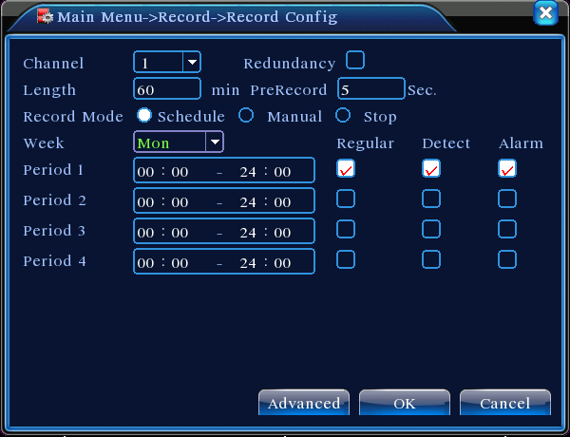
Picture2 Record Config
【Channel】Choose the corresponding channel number to set the channel. Choose the “all” option to set the entire channels.
【Redundancy】Choose the recording file and backup in two hard disks. The one is read-write disk, another is redundant disk.
【Length】Set the time length of each video file. 60minutes is default length.
【Prerecord】Record 1-30 seconds before the action. (file length is decided by the code stream)
【Record Mode】Set video state: configuration, manual and stop.
Schedule：Record according to the set video type (regular, detect and alarm)and time section.
Manual：Click the “all” button and make the corresponding channel recording no matter it is in any state.
Stop：Click the “stop” button and make the according channel stop recording no matter it is in any state.
【Period】Set the time section of common recording, The recording will start only in the set range.
【Recording Type】Set recording type: regular, detection or alarm.
regular：Perform the regular recording in the set time section. The video file type is “R”.
detect：Trigger the “motion detect”, “camera mask” or “video loss” signal. When above alarm is set as opening recording, the “detection recording” state is on. The video file type is “M”.
alarm：Trigger the external alarm signal in the set time section. When above alarm is set as opening recording, the “detection recording” state is on. The video file type is “A”.

7.Snapshot Storage.(partial devices supported)
Setup snapshot parameters for different channels.At first time it's set for 24hours snapshot continuously, pls go to Main Menu->Record->Snapshot Storage for appropriate settings.
Note:If normal snapshot storage,pls setup Snap at MainMenu->Advanced->HDD Manage->Snapshot.
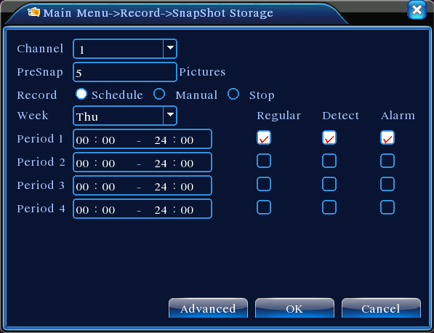
Picture3 Snapshot Storage

8 Video Playback
There are two methods for you to play the video files in the hard disk.
1. In the desktop shortcut menu.
2. Main Menu>Record>Playback.
Note: The hard disk that saves the video files must be set as read-write or read-only state.
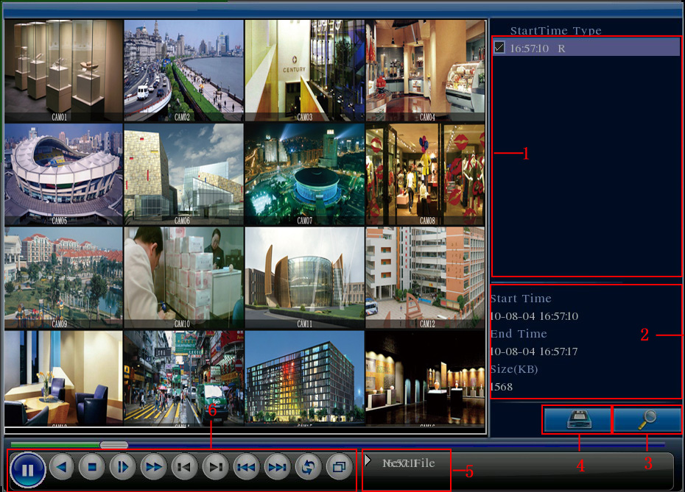
Picture4 Video Playback
1.File option 2.File information 3. File searching
4.File Backup 5. Operation hint 6.Playback control

【File option】Choose the file to playback/backup.
【File information】Start time,end time and size.
Note: The storage must be large enough before the file backup.
【File searching】Search the file according to the searching parameter.
【File Backup】Backup files from HDD
【operation hint】Display the function of the cursor place.
【playback control】Refer to the following sheet for more information.
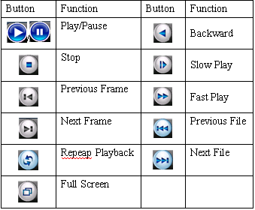
Table2 Playback control key
Note: Frame by frame playback is only performed in the "pause" playback state.
Special functions:
Accurate playback:Input time (h/m/s) in the time column and then click playback.
Local zoom:When the system is in single-window full-screen playback mode, you can drag your mouse in the screen to select a section and then left click mouse to realize local zoom. You can right click mouse to exit.

9 Network Setup
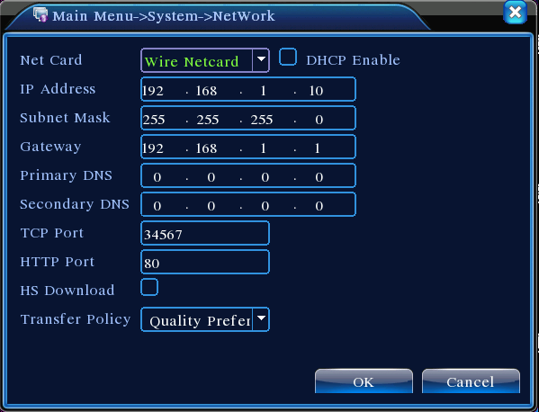
Picture5 Network Setup
Doing network setup through Main Menu>System>Network
【IP address】Set the IP address. Default: 192.168.1.10.
【Subnet Mask】Set the subnet mask code.
Default: 255.255.255.0.
【Gateway】Set the default gateway. Default: 192.168.1.1.
Make the equipment’s IP address and the router in the same network segment. For example, the router IP address is 192.168.1.1, and the subnet mask is 255.255.255.0. According to the default setup, generally the default gateway is the router IP address, so enter IP address 192.168.1.10 in the IE browser to achieve visiting LAN equipment such as operating image surveillance in the public network remote access equipment for monitoring. Detail setup refer to “Network setup reference”.

10 Alarm Setup
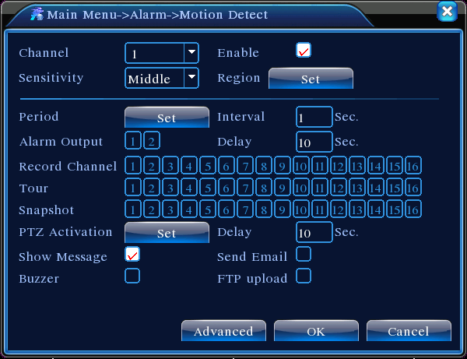
Picture 6 Motion Detection
Motion detection setup. Set DVR equipment making it alarm, linkage record and make the PTZ turn to preset position when there is a moving object in designated areas during Monday to Friday.
Step1. Choose【Main Menu】>【Alarm】>【Motion Detect】，then enter the setup interface;
Step2. Choose one channel and adjust sensitivity level, then set the time period of alarm surveillance. Set the monitor area(click the “set” button, choose the areas you want, and the “default” means choose all areas, then righclick to choose "up window".
Step3. When at alarm state, the DVR can take linkage measures. Alarm output, recording, tour, PTZ activation, snapshot,show message, sending email and buzzer.
Step4. Set other channels alarm parameter following step 2 and step 3.
Note: video block, video loss and alarm input’s setup method are similar with motion detection.

10 PTZ Control
Through the following steps doing easy PTZ operations.
Step1. Set basic parameter such as channel and protocol. 【Main Menu】>【System】>【PTZ Config】
Step2. At the state of menu preview, enter the PTZ operation menu.
Step3.One is "rightclick" mouse, choose the “PTZ control” and doing the PTZ general operation. The other method is "rightclick" mouse, choose “High Speed PTZ”. Control the left button and move it to control the PTZ direction directly. Use the mouse wheel to zoom in/out the controlled camera.

The Second Part: Remote Control

1 Network Connection
Before web operation,you need to connect the equipment with internet.
Step1.Connect the equipment with the internet correctly.
Step2.Set LAN following to the ninth term Network Setup in reference manuals first part.
Step3.when Lan is connected,it needs to set up port mapping for public network access.
Step4.DDNS Application.You can apply for DDNS in the http://www.3322.org/ and http://www.oray.com/
Step5.DDNS Setup.Make sure to fill the right info in the Main Menu->System->NetService->DDNS
Note:The device must be in the same network with PC,if cannot connect,pls check the device IP if it works fine.

2. Remote Monitoring
After connecting the network, two kinds of methods can be used for remote monitoring which are client software and common browser.Client software(CMS) is professional software used in multi-equipments monitoring, which is safe, convenient and stable. It is the better one that we advise customers use it. And the browser comes with system such as IE browser.

2.1 Client software
CMS software is used in a computer, and manipulates several DVR at the same time.
Step1. Please take CD out of the accessory box, then copy CMS installed software in it.
Step2.After installing this software at the local PC, then open the operation system as in picture 6,Enter the add device interface through【System】>【Device Manager】>【Add area/device】, and enter DVR information which is needed manipulating following the prompts, in that way, you can manipulate any specified equipment. And the method is the same with web manipulation’s.
Step3. You can add several DVR more to do monitor operation if you repeat this operation.
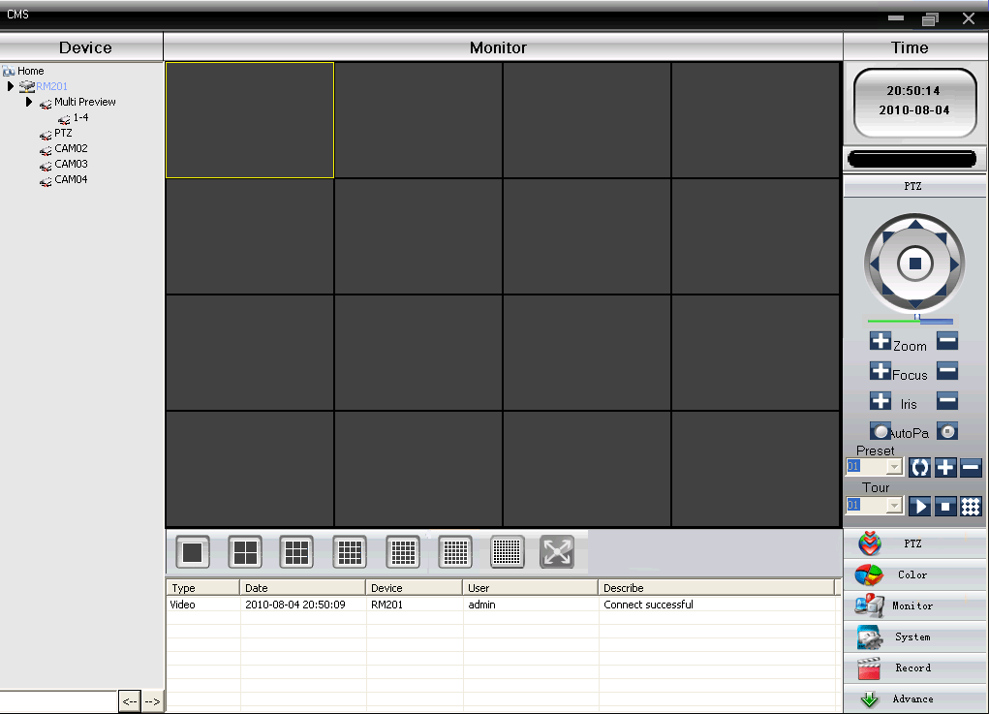
Picture 7 CMS Interface

2.2 WEB
After the network connecting, using the browser comes with computer login DVR to do remote monitoring.
Step1. install the plug. Open the disk, then get General_IE_V2.0.0.35_20111222.exe and install.
Step2. Connect the equipment. Open web browser, then enter IP address on the address bar of the equipment. For example, the IP address of the equipment is 10.6.0.114, and then you should enter http://10.6.0.114 on the address bar to connect.
Pop up as follows interface after connecting successfully.
Note: when first login, see below picture
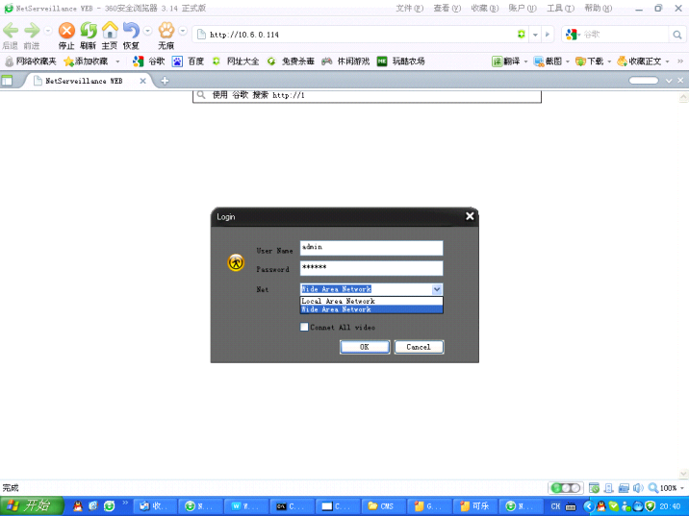
Picture 8 Web Login Interface
Step3. Login. Enter user’s name and password, the default Administrator User ID is admin, and the password is admin. The user should change the administrator’s password timely after loginning in.(If choose "Local Area Network",it's Main streams,if "wide Area Network",it's Sub streams.)
You will see as follows interface after loginning in.
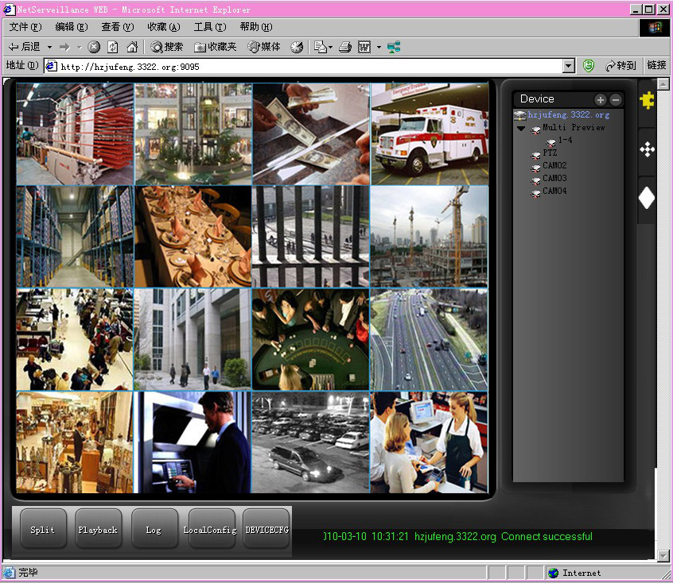

Picture 9 WEB operation interface

3. Basic Web Operation
Do web operation in picture 8 web operation interface
1) Screen Split
Choose image preview mode;
2) Playback
Enter playback mode, which supports multi-channel playing back simultaneously.
3) Log
Display log information；
4) Local Config
Alarm and System setting
5) Channel operation
Open the videos. Left click and choose a window in the left, and choose the corresponding channel in the right, then double click the video. Open the second channel’s video, choose the left window, then select the corresponding channel in the right, after then, double click the video. Opening other channels is the same way. If you have chosen the window of opened video, then open other channels in the right, the system will close all the channels and open new channel. Customers can adjust image mode upon opened video channels.
Close the channel. Rightclick mouse at the channels which are needed to close. Or choose to close all the windows to close opened video channels.

The Third Part: Special Function
This series become more personalization design and visualization operation press key,local enlarge at any areas in preview interface,timing start up and shut down,FTP upload,3G&WIFI and so on.Now let's introduce Encode,Multi channels playback and mobile monitor setup.

1 Coding Config
DVR achieves the functions such as high quality playback and remote monitoring by coding parameter config.
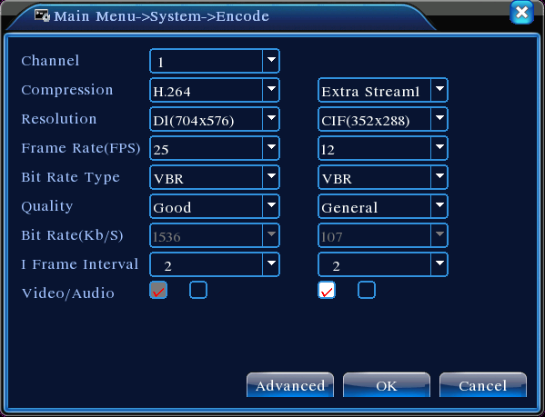
Picture 10 Encode setup

1.1 Encode setup for every channel
Note: Only part of DVR mode support resolution switch.
Step1. Local operation through 【Main Menu】>【System】>【Encode】（remote setup click right mouse and choose “config” in【System】>【Encode】）.
Step2. Choose channel 1, set the resolution as D1 (25fps, 1536Kb/s)
Step3. Choose channel 2, set the resolution as CIF (25fps, 512Kb/s). Click right mouse or choose “Advanced” then click “Copy” button.
Step4. Choose channel 3, click the right button or choose the local “Advanced”, then choose “Stick”. Channel 4’s operation is the same with channel 3.
Step5. Click “save”, then exit.
Note: standard parameter between resolution and Kb/s.
Resolution | Kb/S
D1 | 512~2560
HD1 | 384~2048kbps
CIF | 64~1024kbps
QCIF | 64~512kbps

1.2 Extra Stream Setup
Extra stream is used for remote client monitor and mobile monitor area.
Step1. Enable extra stream
Step2. Set frame rate and bit rates,operation way is the same as main stream.

2 Multi-channel Playback Simultaneously
DVR introduces the newest combination coding technique to achieve videos of all channels play simultaneously.
4 channel DVR can support 4channels playback simultaneously,8 channel DVR can support 8channels playback simultaneously,channel number can be free chosen.
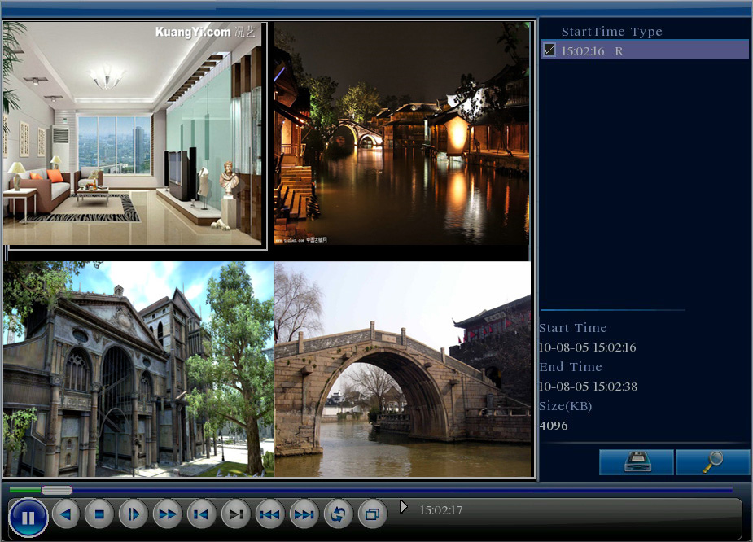
Picture11 Video Playback
Step1. Set every channel’s encode parameter by 【Main Menu】>【Record】>【Encode】.
Step2. Enter video playback interface, click Search button.
Step3. Choose File Type and All and time period, then click OK in Search Condition interface.
Step4. Choose the record file, then click Play or double click the file to playback in playback interface.

3 Multi-channel Real-time Monitor remotely
Introduce extra-stream techniques to achieve multi-channel remote monitoring simultaneously in the condition of narrow band(poor network speed)
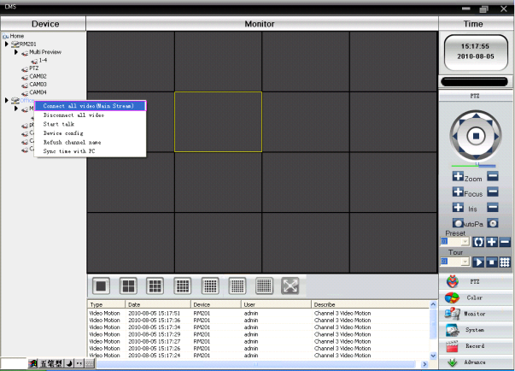
Picture12 CMS Interface
Step1. Enable extra streams(MainMenu->System->Encode)
Step2. Open CMS, and then login.
Step3.After add devices,rightclick device name to select "Connect all video(Main stream)"

4 Mobile Monitoring

It introduces extra stream techniques when mobile monitoring,support channels switch(eg. Windows mobile)
Step1. DVR config,go to MainMenu->System->Encode->
Extra Stream,enable it.
Step2. Setup mobile monitor, go to MainMenu->System->
NetService->Mobile Monitor,choose "Enable"
Note: Pls map the mobile monitor port in the router first,then you can use mobile to visit it.
Step3. Intall the corresponding mobile monitoring software through CD (Software->Mobile Monitor->MEYE->
MEYE_WM.cab)
Step4. After successfully installing the software,finding and running "eg.windows mobile-moveeye" software through [start]->[procedure] in the mobile,see picture 14
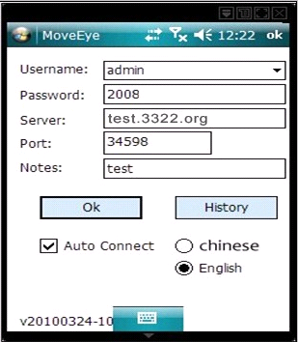
Picture13 mobile client software Interface
Step5.Mobile setup.Click "setting" button at the right corner,then go to below picture 15.
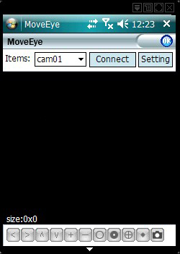
picture 14 mobile client software setting
User name: login name of DVR
Password: password of DVR
Server: IP address or domain name of DVR
Port: mobile monitor port of DVR,pls refer to Step 2.
Auto Connect:If select it,then it will auto connect to the DVR and auto display cameras.
Note:DVR need to be connect to public net when mobile monitor
Similar setup between different operation system:
Symbian S60 the 3rd operation system mobile monitoring client software: MEYE_SB_S60_3rd.sisx
Symbian S60 the 5th operation system mobile monitoring client software: MEYE_SB_S60_5th.sisx
Android mobile monitoring client software:MEYE_Android.cab
Blackberry mobile monitoring client software:MEYE_RIM.cod
Iphone mobile monitoring software: use mobile to search "vMeye" in the appstore and install it online.

5 Flexible File Storage and Backup
DVR introduces several unique storage and backup techniques to achieve multiple modes storage and backup.
Real-time storage
Redundant storage. DVR introduces RAD 1 storage technique to achieve two hard disks storing simultaneously and mutual backup.
USB HDD and movable hard disk. DVR introduces the storage technique, supporting video files which are real-time written in storage devices.
DVD-RW. DVR introduces the newest real-time storage technique, supporting video file which are burnt real-time to CD.
Real-time remote storage. DVR supports video files real-time storing to computer devices(Disk C/D/E/F) at the remote client.
File download
Using U disk and movable hard disk download at local device, DVR supports the chosen file are high-speed backup to the storage devices.
DVD-RW. DVR supports the chosen video file are burnt and stored as CD.
Network high-speed download. DVR supports high-speed down loading the chosen file at remote client.

Appendix 1. Remote controller operation

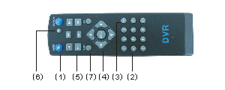

Serial number | Name | Function
1 | Multi-channels button | Multi-channels preview
2 | Number button | Password input/number input/ channel switch
3 | 【Esc】 | Back to up window
4 | Direction button | Direction and OK button
5 | Playback operate | Playback Basic operation
6 | Record control | Enter into record menu
7 | Remote controller | Input the number of DVR to control it
8 | FN | Assistant function

Appendix 2.Mouse operation

*Take right hand as an example
Operation | Function
Double left click | Double click one item in the file list to playback the video  Double click the playback video to zoom in or out the screen
Double left click | Double click the channel to make it full screen display in preview  double click again to resume the multi-channel display
Left click | Choose according option in the menu
Right click | Pop desktop shortcut menu in preview state
Right click | Current shortcut menu in the menu
Wheel button | Add or subtract number value in the number setting
Wheel button | Switch the items in the combo box
Wheel button | Page up or down in the list
Move mouse | Choose the widget or move the item in the widget
Drag mouse | Set the motion detect area
Drag mouse | Set the cover area

PRODUCT WARRANTY CARD

All the products sold are covered by 12months warranty from the date of invoice.
Warranty instructions：
1. Please contact us when the product is caused by its own fault within 1year warranty.
2. Please mail us your written warranty card as soon as possible after purchasing our products so that we can repair or replace this product to its original operation condition for free. Or the company will not deal with it.
3. Please write the truth information on the warranty card.
4. Paid for repairing as follows:
A: Equipment failure caused by human operation
B: Equipment failure caused by not conforming to the using environment
C: No warranty card
D: Warranty expired

Warranty card information:
Product model Product serial number Purchasing time
User name Contact person Telephone
Distributor Name Contact person Telephone

Note：Please keep the warranty card for the better service.

